How to Install Remote Desktop application

&

Access Broadridge Window Virtual Desktop

Charlie Joshua

*05/01/2020*

**Download and Install Remote Desktop application**

1. Download the Remote Desktop app from <https://docs.microsoft.com/en-us/azure/virtual-desktop/connect-windows-7-and-10> and run the Remote Desktop exe

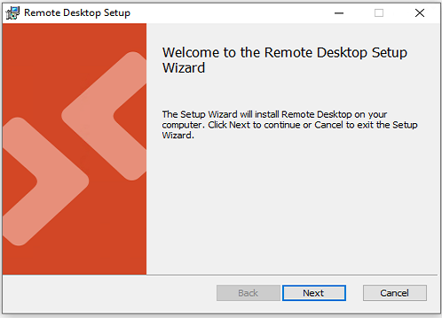

1. Click on Next and Accept the agreement

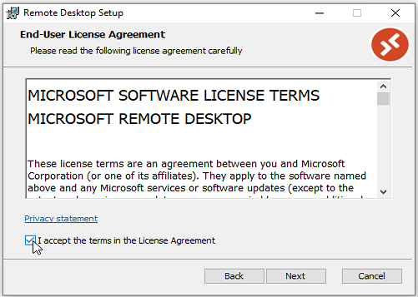

1. Select “Install just for you” and this will install in the current user’s profile

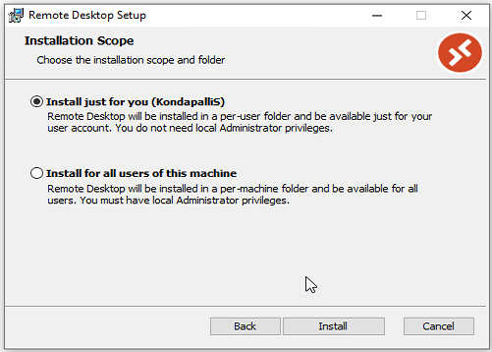

1. Click on Install and let the installation complete

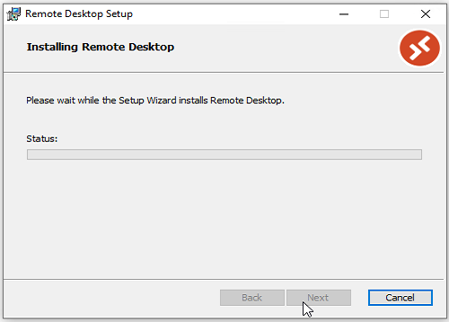

1. Click on Finish and Launch the Remote Desktop Application.

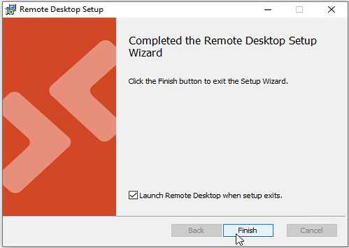

**Configure Remote Desktop App and Symantec VIP**

1. After the installation is complete and the application is Launched, Click on Subscribe

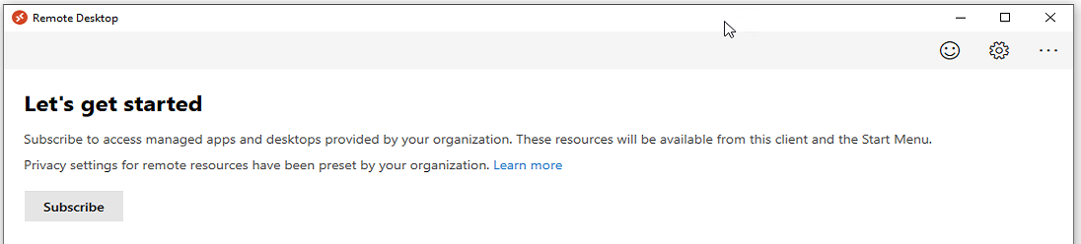

1. In the Pop up windows enter your email address and click on Next

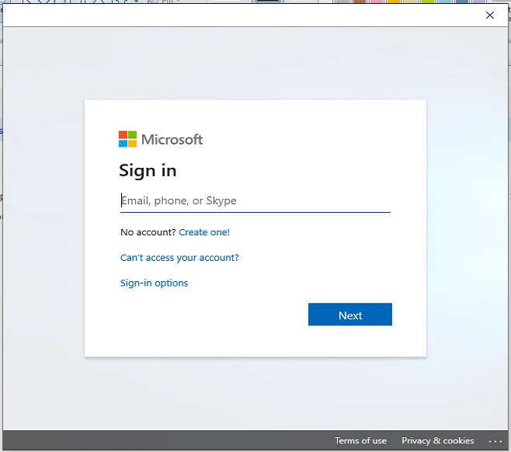

1. The page will be re directed to the SSO page for authentication, provide your windows password and click on Sign in

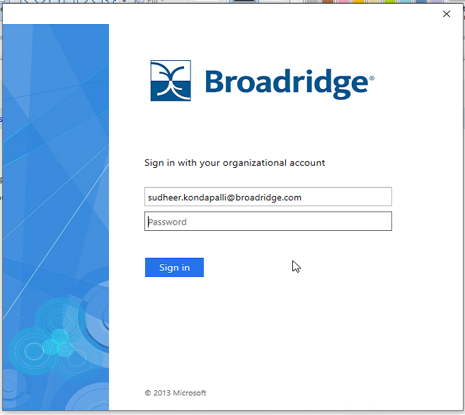

1. If your Symantec VIP is *not registered* with your email ID you will be redirected to the VIP configuration page as below. If it is registered, please continue to *Access WVD through Remote App section*.

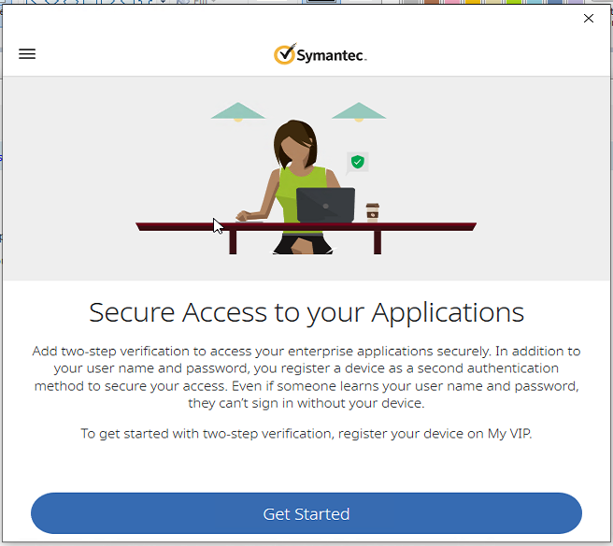

1. Click on Get Started and Select “VIP Access Mobile”

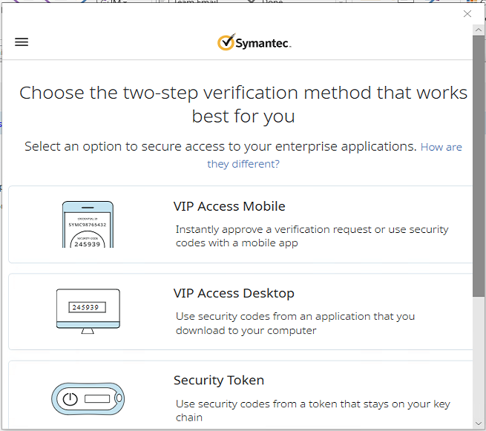

1. This will start the VIP Access Mobile configuration. Please ensure you have Symantec VIP installed on your Mobile and Select continue

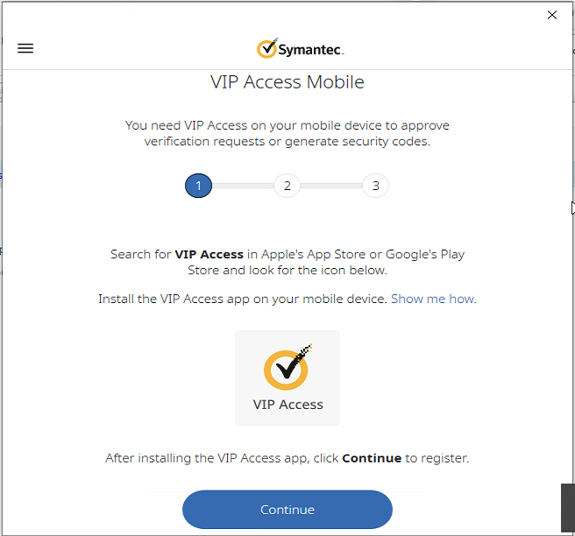

1. If you have a Camera you can scan the QR code to register and If you do not have a camera click on Register Manually and follow the next steps

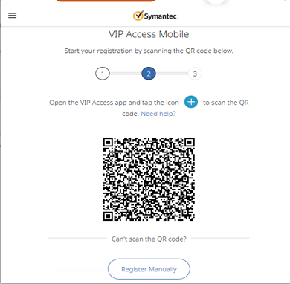

1. Enter your Credential ID from the Symantec App on your mobile and click on Continue

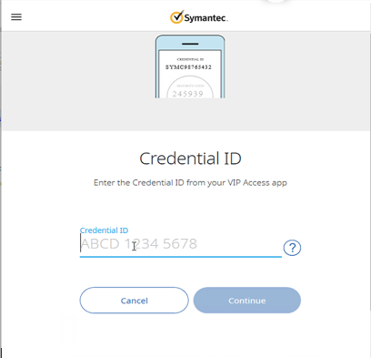

1. Enter the Security code and Click on Register

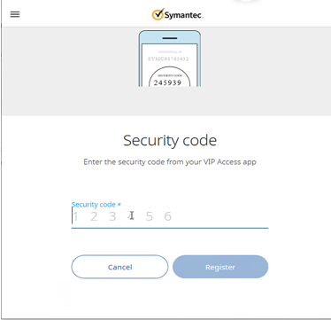

1. Symanec VIP Will be registered, Enter a Friendly name to remember the Device

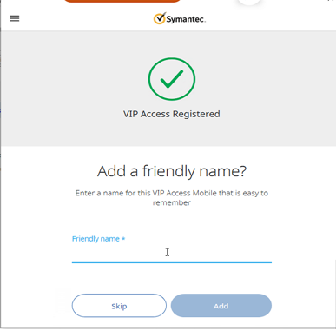

1. Once the VIP is registered properly you can choose to test and verify if token is registered correctly

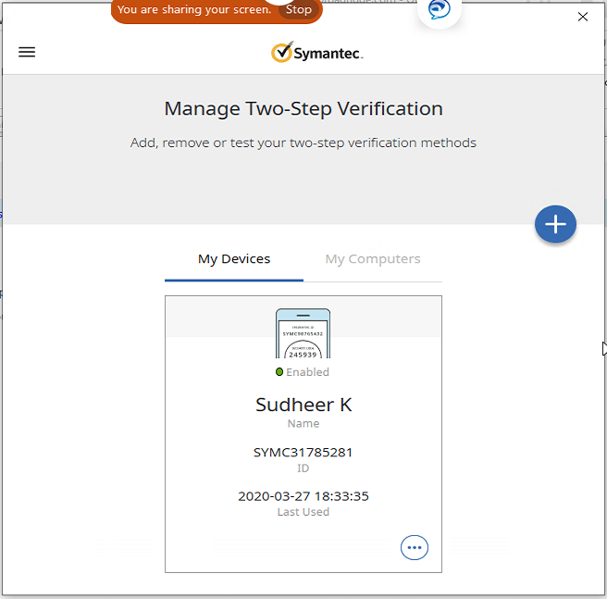

**Access WVD through Remote App**

1. Open the Remote App and click on Subscribe



1. In the Pop up windows enter your email address and click on Next



1. The page will be re directed to the SSO page for authentication, provide your windows password and on Sign in

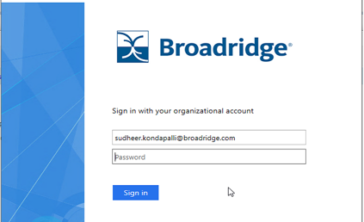

1. As your Symantec VIP is registered, token request will be sent to Symantec VIP on your mobile Device to approve. If you get an error please select “Use another option to Sign in”

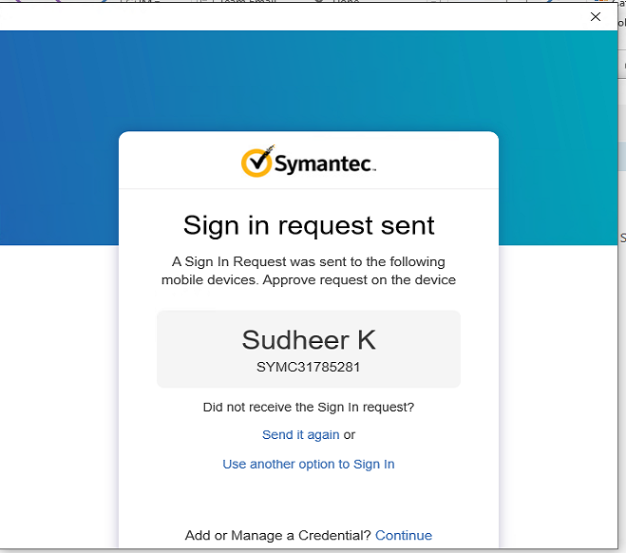

1. When you select another option, it will request you for the security code on your Symantec VIP App. Please enter the code and click on Submit

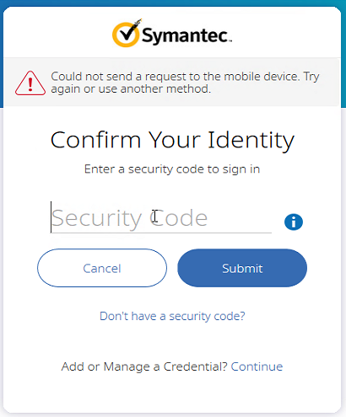

1. Once your token is accepted, you will receive the below option, select “This App only” and you will be set to login to Remote Desktop App

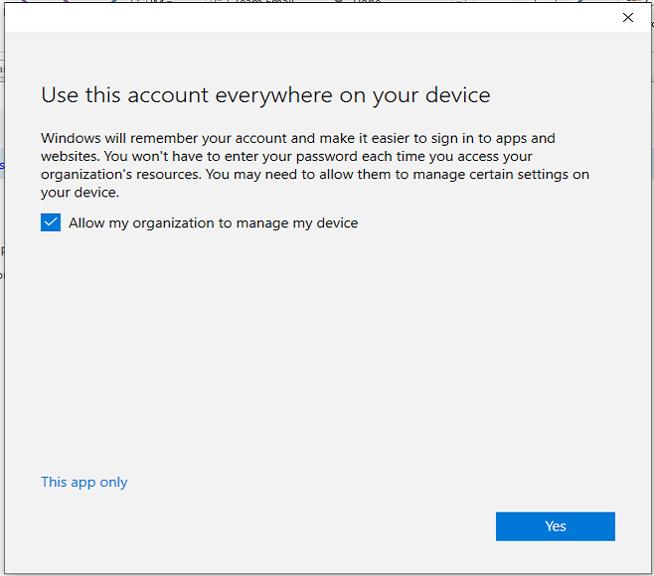

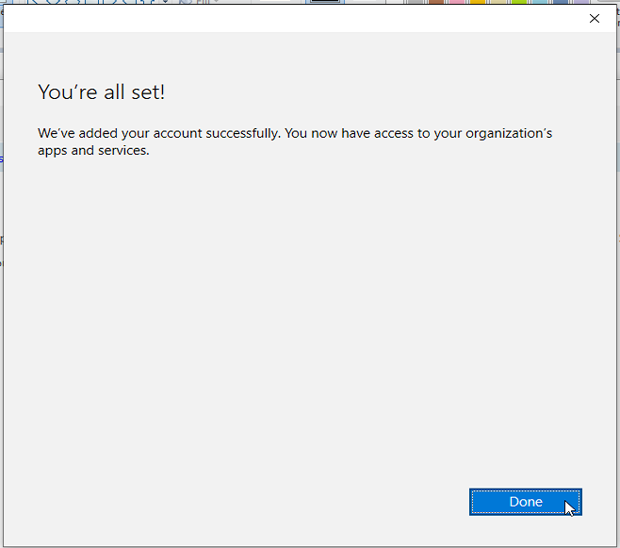

1. Double click on the WVD icon displayed and let it launch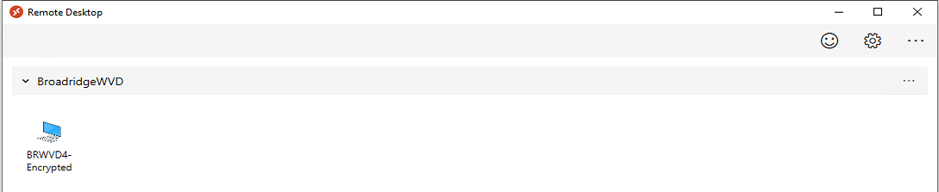

1. This will connect you to the WVD and request for your credentials

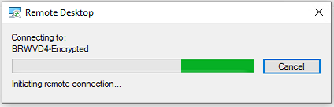

1. Enter your Windows Credentials and you will be connected to the WVD

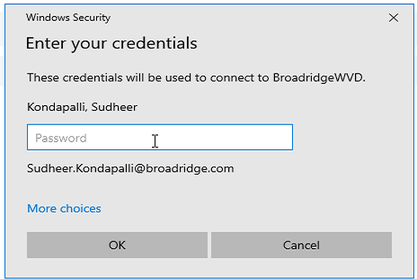

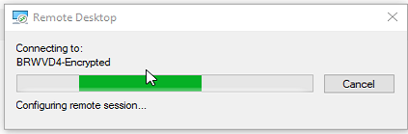

1. Here is your Brand New Azure WVD. Please go through the regular steps of configuring your outlook, Teams and Jabber like in your regular Desktop/Laptop .